freETarget
Application Note: FreeETarget Traffic Lights

CAUTION

When using freeTarget:

- Wear eye protection
- Maintain a safe distance
- Do not shoot into any areas except the open target areas.

The freeETarget project or contributors will not be responsible for any injuries when using this target of it’s components.

Target shooting can be dangerous so apply caution in everything you do.

SUMMARY

The FreeETarget Traffic Lights is an accessory that informs the shooter of a timing interval. Applications include

- Turn on and off a Rapid Fire event
- Used as a Tabata timer to train against over holding

CIRCUIT DIAGRAM

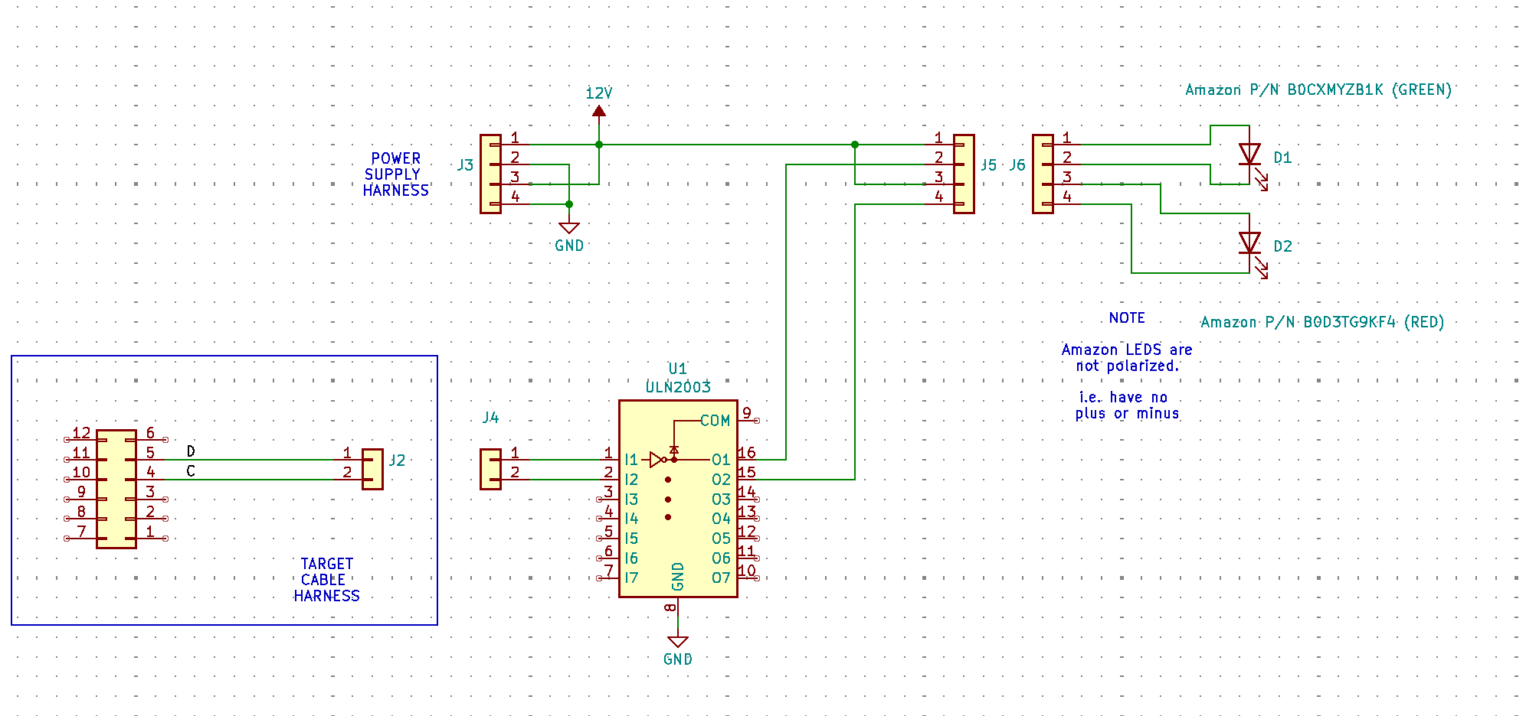

Circuit Diagram The components are available from Amazon

CONNECTIONS

The connector (J1) attaches to the MultiFunction connector (J1 on the circuit board) so that C, D, and GND line up with pins 4,5, and 6.
The loose RED wire attaches to the +12 supply

MFS SETTINGS

The Traffic Lights requires the following configuration to be applied to the Multi Function Switches

{"MFS_HOLD_C":18, "MFS_HOLD_D":20, "MFS_SELECT_CD":22}

TESTING

Once configured with the settings above, the Traffic Light indicators will cycle
- RED
- GREEN
- OFF
When powering up the board.
The lights will go off unless used in Rapid Fire or Tabata

